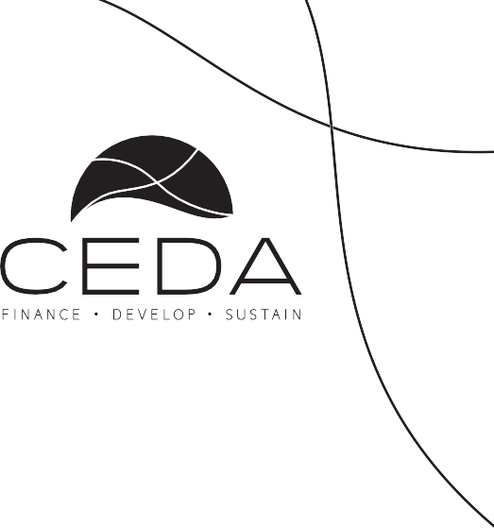
BOS ISO 9001
BOBS
F
O
Certified
U
A
E
R
U
B
S
D
R
A
D
N
A
Organisation
T
S

LETLHABILE LOAN
APPLICATION FORM

COMPANY/APPLICANT DETAILS
Business Name/ Applicant |  | Company No:
Date of Incorporation/ Start Date of operation
Contact Person |  | Tel:
Nature of business
Business Location
Loan Amount (BWP)
Name
Signature
Date
F
O
Certified
U
A
E
R
U
B
S
D
R
A
D
N
A
Organisation
T
S

Personal Details (If Company, complete for all Shareholders)

Title | Mr | Mrs |  | Miss | Other (State title)
Surname
Other Names
Omang Number
Date of Birth
Marital Status (tick the correct one) | Married |  | Single |  |  | Divorced
Postal Address
Physical Address (Owned/ rented)
How long have you been at this address |  |  | Telephone
Email
Name and Address of Employer

Title | Mr | Mrs |  | Miss | Other (State title)
Surname
Other Names
Omang Number
Date of Birth
Marital Status (tick the correct one) | Married |  | Single |  |  | Divorced
Postal Address
Physical Address (Owned/ rented)
How long have you been at this address |  |  | Telephone
Email
Name and Address of Employer

- Next of Kin Details

Name (in full) | Date of Birth | Nationality | Omang No. | relationship | Contact details | Physical address

F
O
Certified
U
A
E
R
U
B
S
D
R
A
D
N
A
Organisation
T
S
Project Description:

(Give a brief description of the project and how COVID- 19 has affected business operations and where do you see new business opportunities)

  - How did Covid-19 affect your business?

  - How long have you been operating your business?

  - Which location do you mostly sell from?

  - Who are your customers and how do they get to buy from you?

  - Where do you usually buy stock and how often do you buy in a month?

  - Do you have any credit lines with the suppliers? If yes what are the terms?

  - What is the average cost of stock per month?

  - What products does your business sell?

  - Which product (s) sell most than the others and why?

  - What is the lowest money you make in a day and what is the most money you can make in a day?

  - What are the type of expenses incurred per month and their amounts?

F
O
Certified
U
A
E
R
U
B
S
D
R
A
D
N
A
Organisation
T
S
l)
How will this loan assist your business?
m)
Apart from yourself, how many employees do you have in your business?
n)
Based on your past history, demonstrate how you have been able to pay your debts?

Loan breakdown (Stock, Tools/ equipment, packaging material, transport etc)

Items/ Type | Amount

- Does the company/ promoter have any loans from other Financial Institution? Yes [ ] No [ ]

Financial Institution Name | Account Number | Loan Amount | Repayment Amount | Repayment Period | Amount Outstanding

- Commercial Bankers

Bank Name | Branch
Account Number
Account type (savings/ current , Business etc.)
Telephone | Facsimile

- Did you benefit from any other Government interventions/ Incentives aimed at addressing COVID- 19 Pandemic effects (YES/ NO)
F
O
Certified
U
A
E
R
U
B
S
D
R
A
D
N
A
Organisation
T
S

IF YES (Explain)

LETLHABILE LOAN APPLICATION CHECKLIST (REQUIRED DOCUMENTS) | TICK
1. Certified copy of Omang
2. License to operate business where applicable (hawkers/ trading, Registration Certificate, exemption etc)
3. Company resolution to borrow ( If company)
4. Certified copies of Shareholders & Directors IDs (If a company)
5. Certified copy of Marriage Certificate, where applicable
6. Certified copy of Deeds Marriage Instrument (Form A or B)
7. Certificate of incorporation (If a company)
8. Memorandum & Articles of Association (If a company)
9. Form 2 (If a company)
10. Form 4 & 5 (If a company)
11. Share Certificates (If a company)
12. Company Registration Extract Documents (for companies registered/ re-registered effective 3 June, 2019)
13. Quotations from suppliers
14. Proof of past business activity, prior to the 29th February, 2020 ( Cashbook, Sales book, Invoices & supplier’s receipts etc)
15. Proof of Residential address (Can be verified with Utility Bills that bear the address / Affidavit)

